|  |  |  |  |  |  |
| --- | --- | --- | --- | --- | --- |
| Date | 6-Dec-22 | | | Tester Name | Mayuri Patel |
| Environment | Penfax - Test | | | Login used |  |
| Operating System | Select OS | Version: | Update: | | |
| Software Used | Select Software | Version: | Update: | | |
| Select Software | Version: | Update: | | |
| Release version | 22.4.1 | | | | |
| Title |  | | | | |
| Test Type | Regression | | | | |
| Test Scenario | Process death payment to multiple non-spouse beneficiaries | | | | |
|  |  | | | | |
| Expected Results |  | | | | |
| Pass/Fail | Pass | | | JIRA# | N/A |

Describe your steps with screenshots:

Search for a deferred survivor VPB active member who has multiple non-spouse as primary VPB beneficiary

Open that member Profile

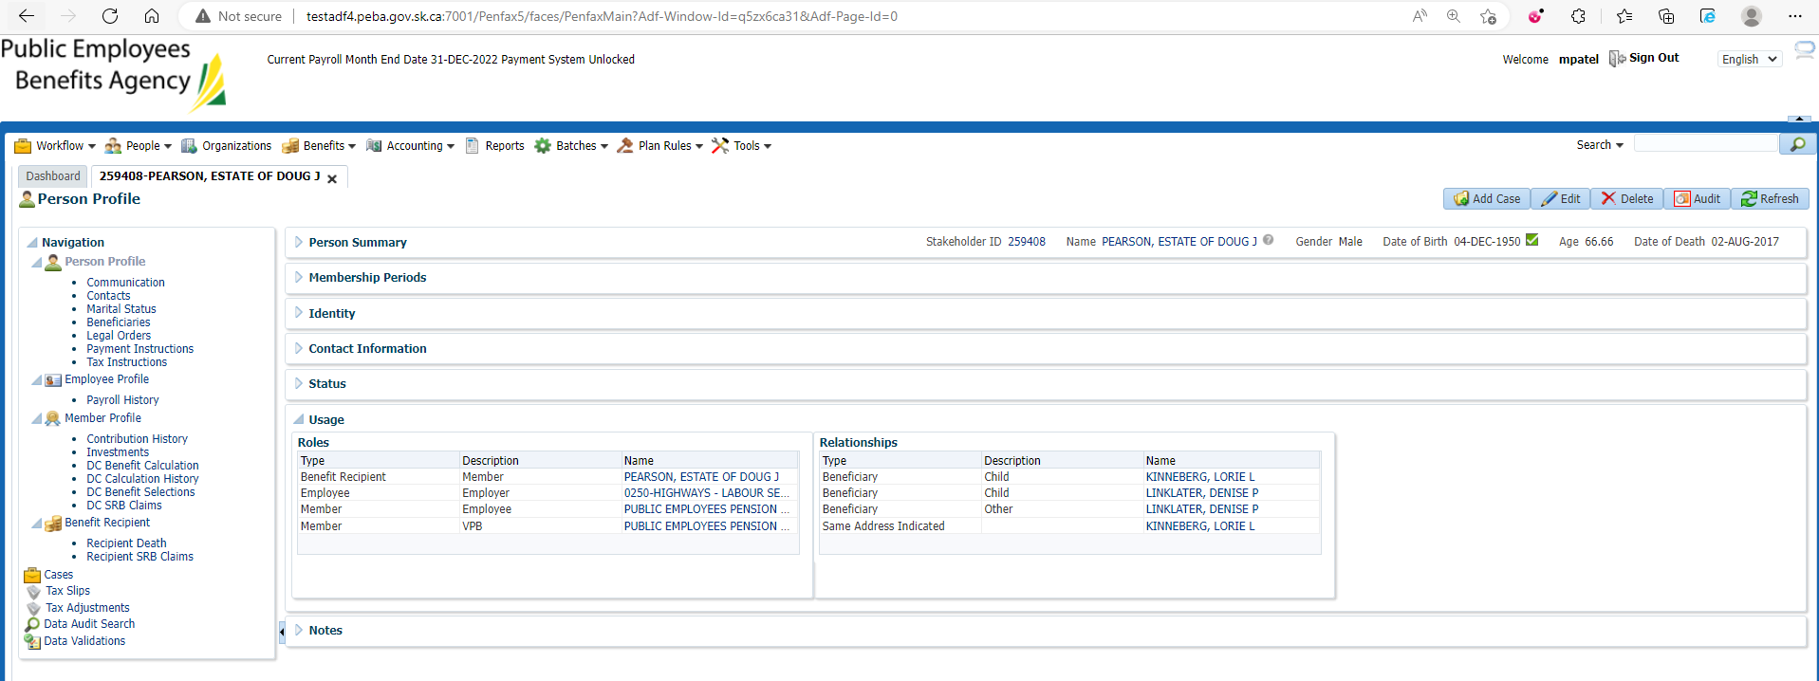

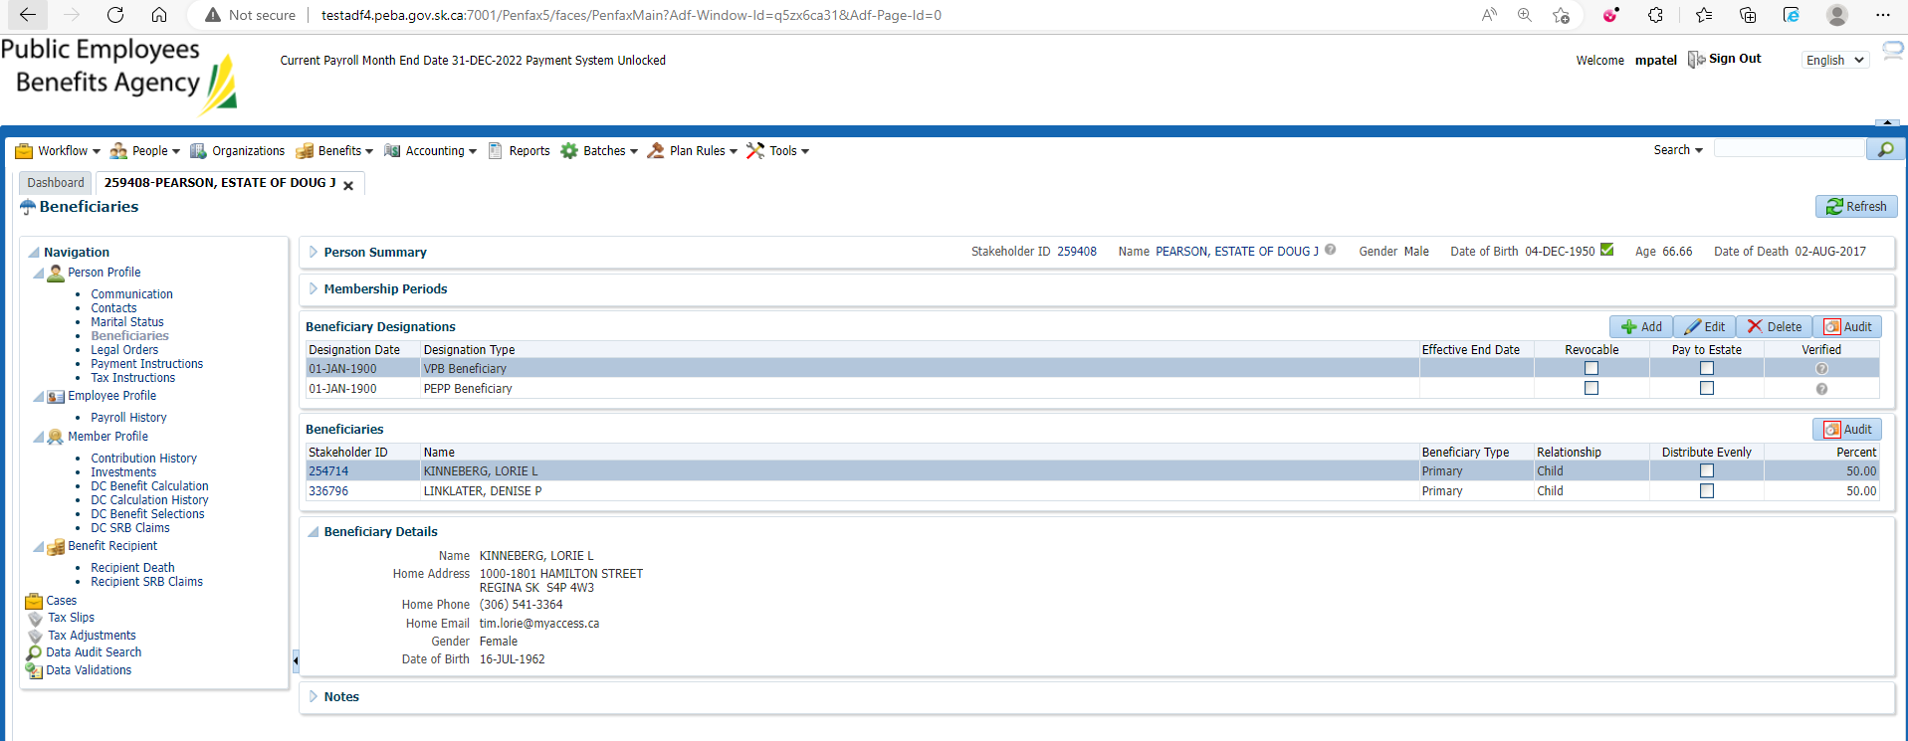

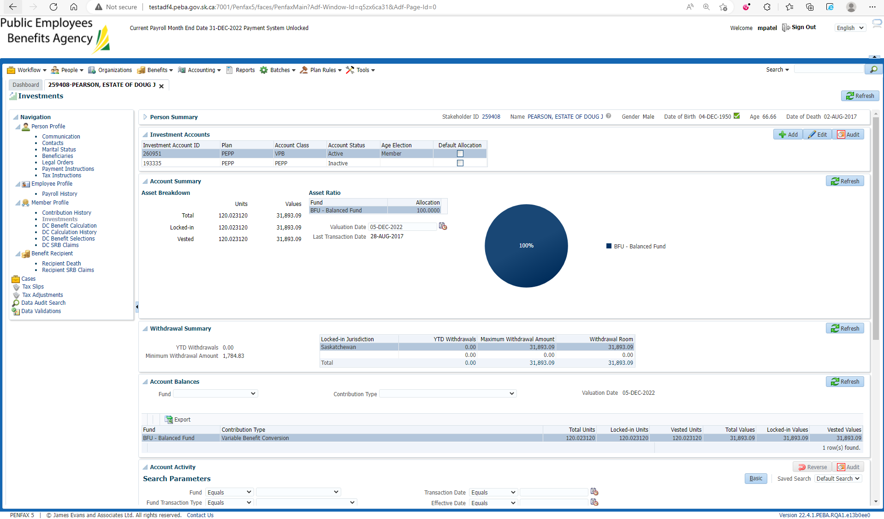

Go to DC Benefit Selection and next

Add allocations and Save

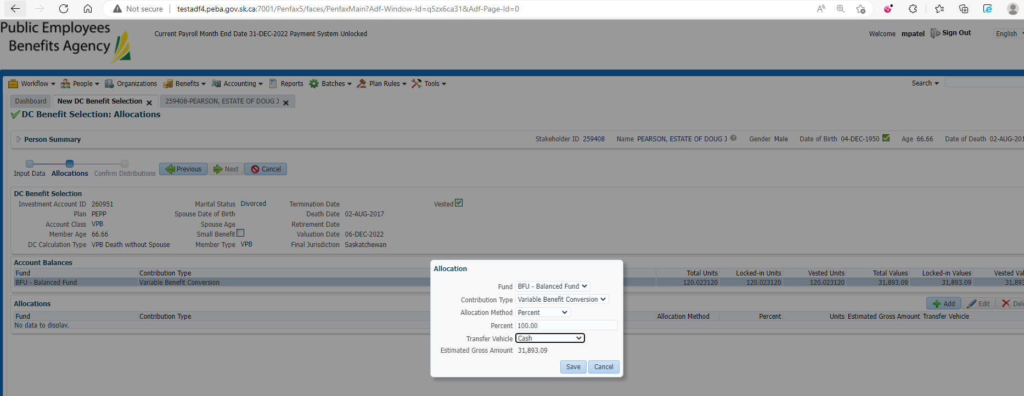

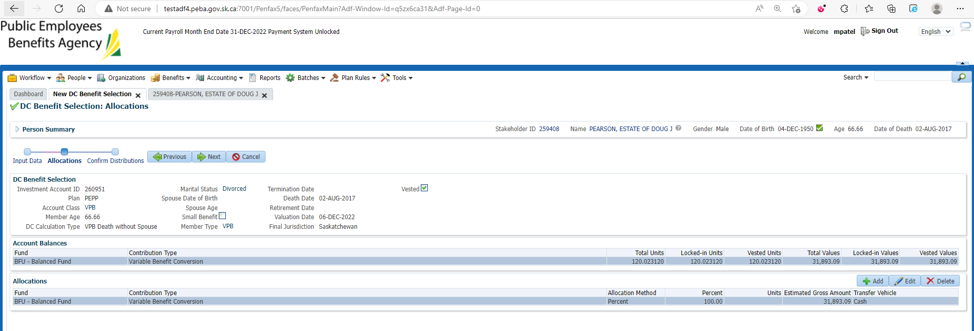

Submit for Approval and Approve it

For Child 1

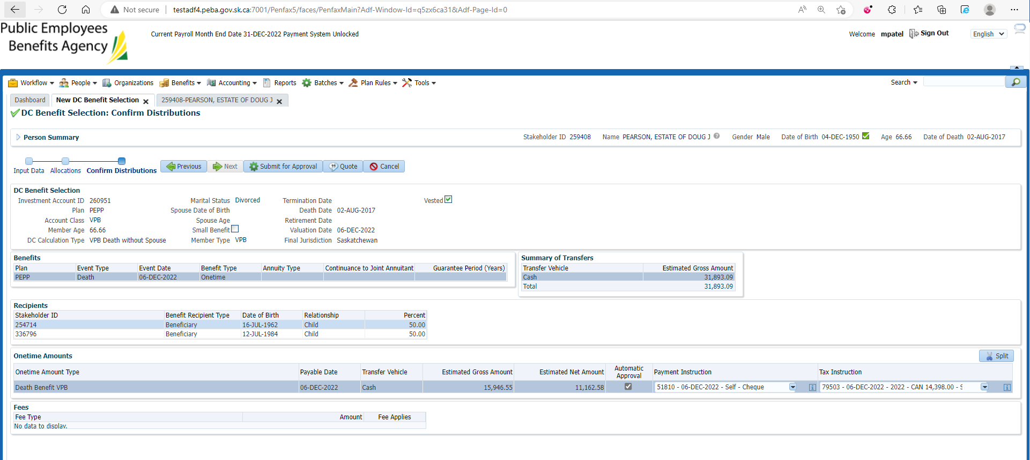

For Child 2

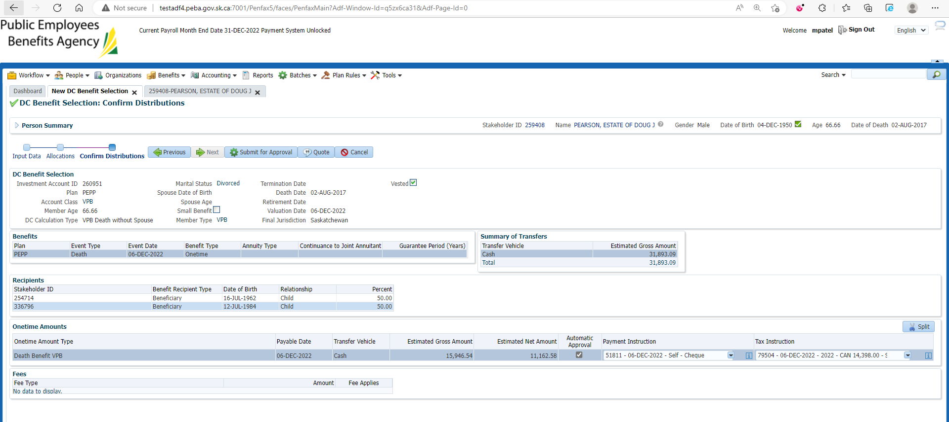

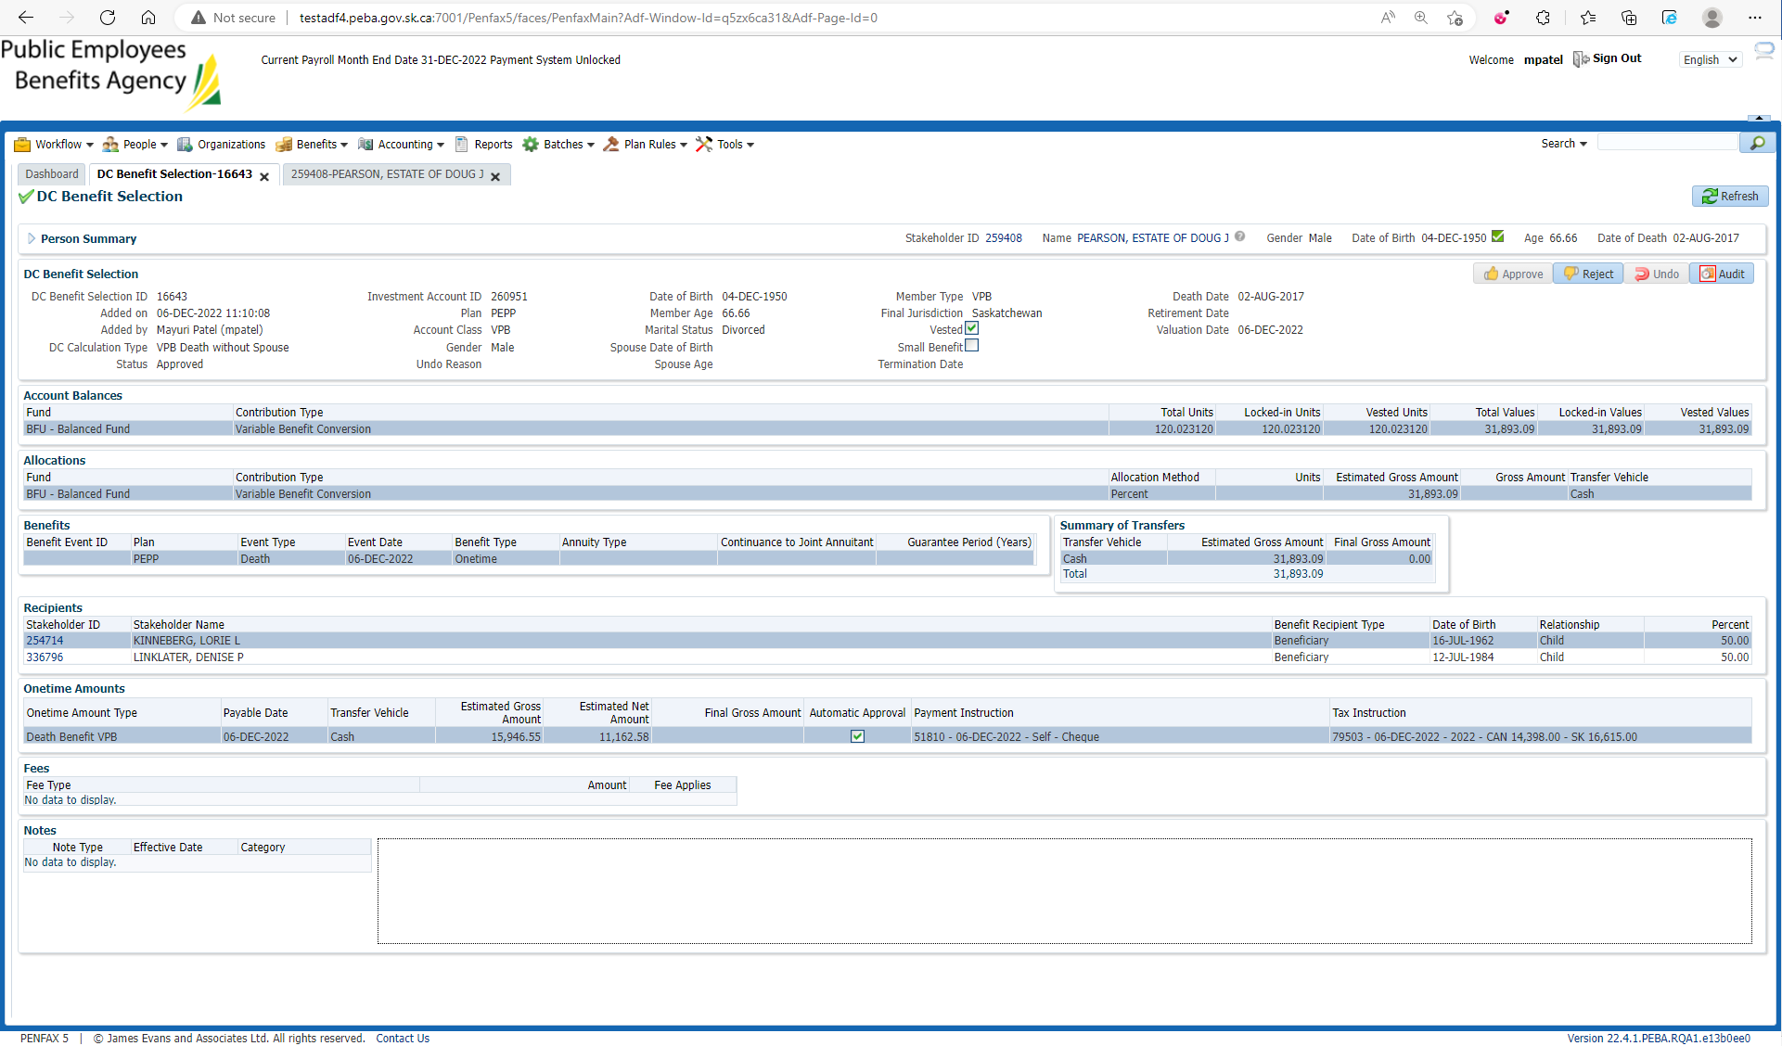

After Overnight PIT Batch

Open VPB beneficiary profile and member profile to make sure about the payment

Benefit Recipient🡪 Onetime Amount

Make sure Death Benefit VPB is processed

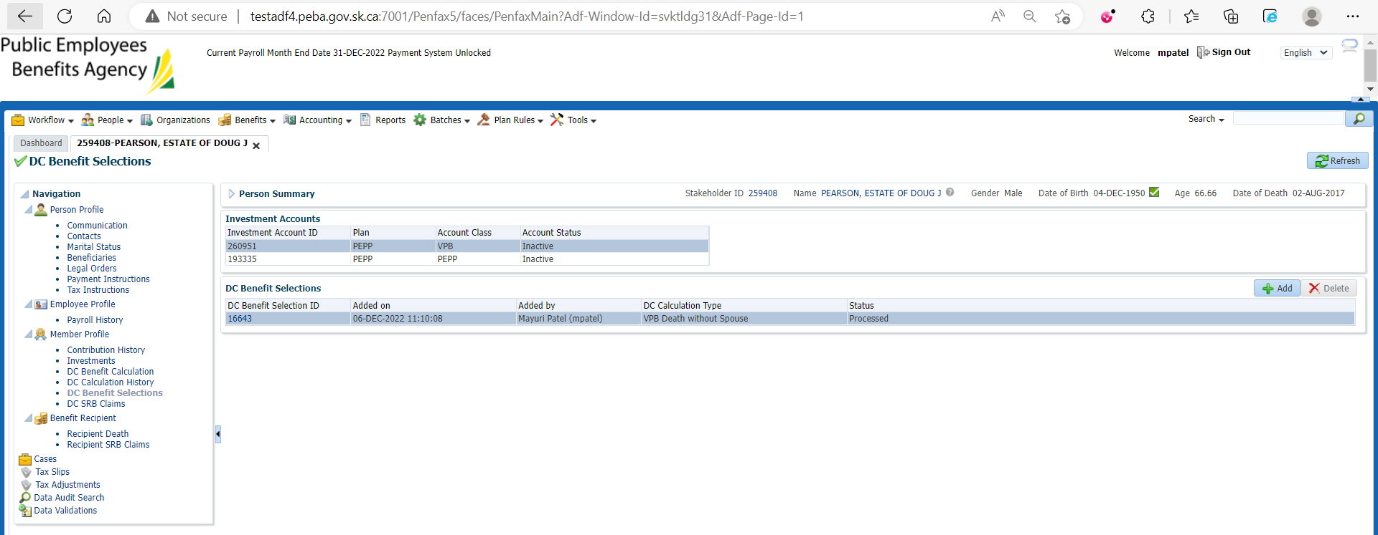

For Child 1

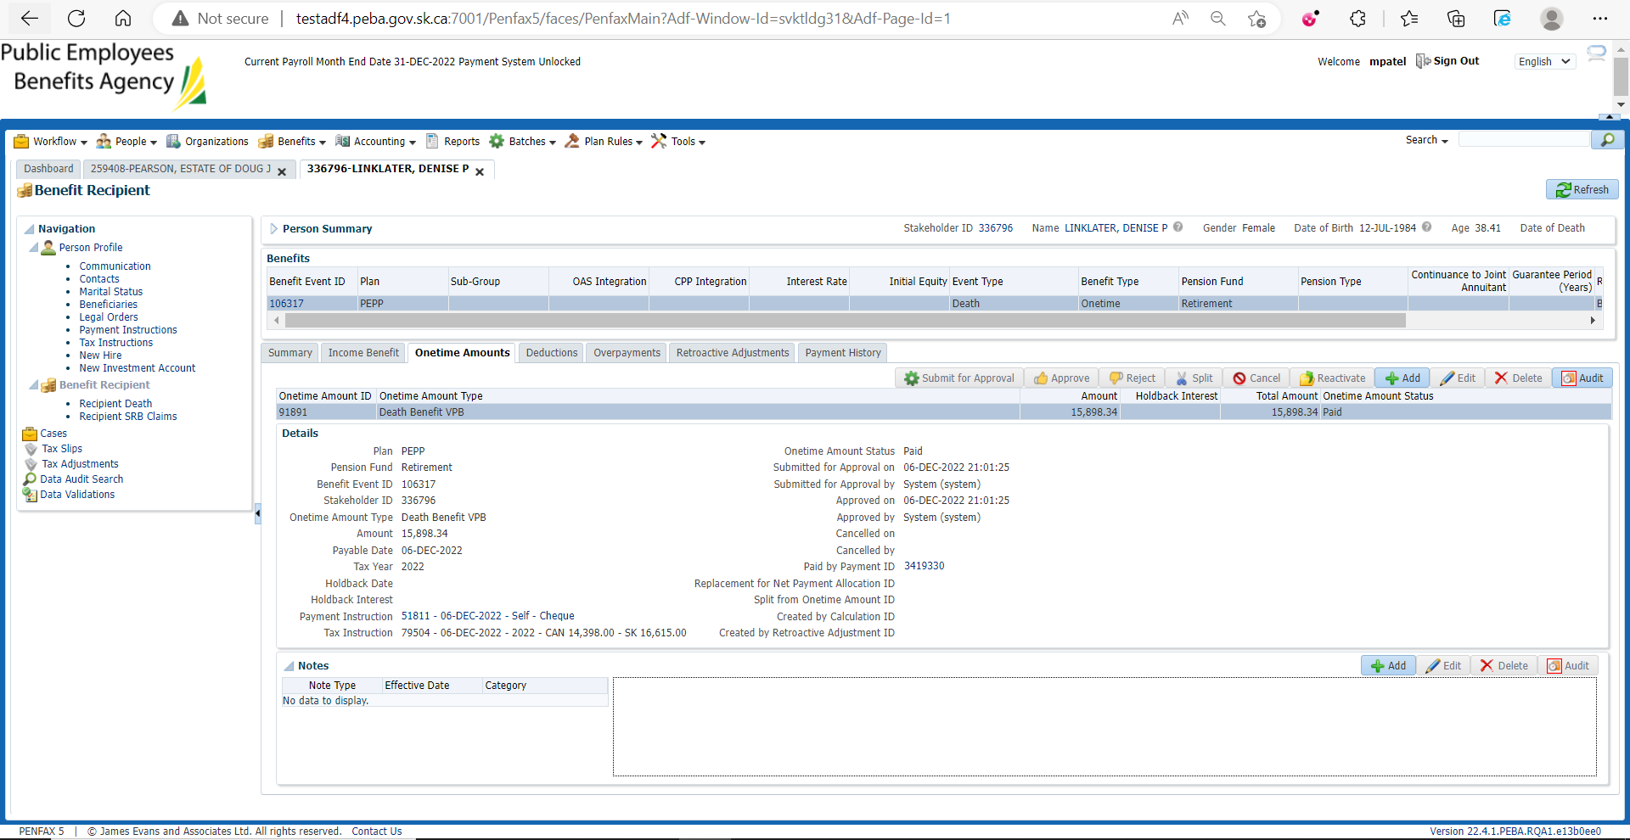

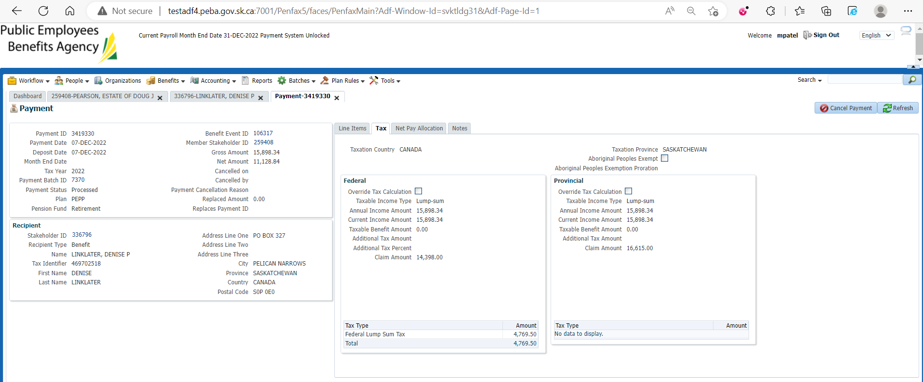

For Child 2

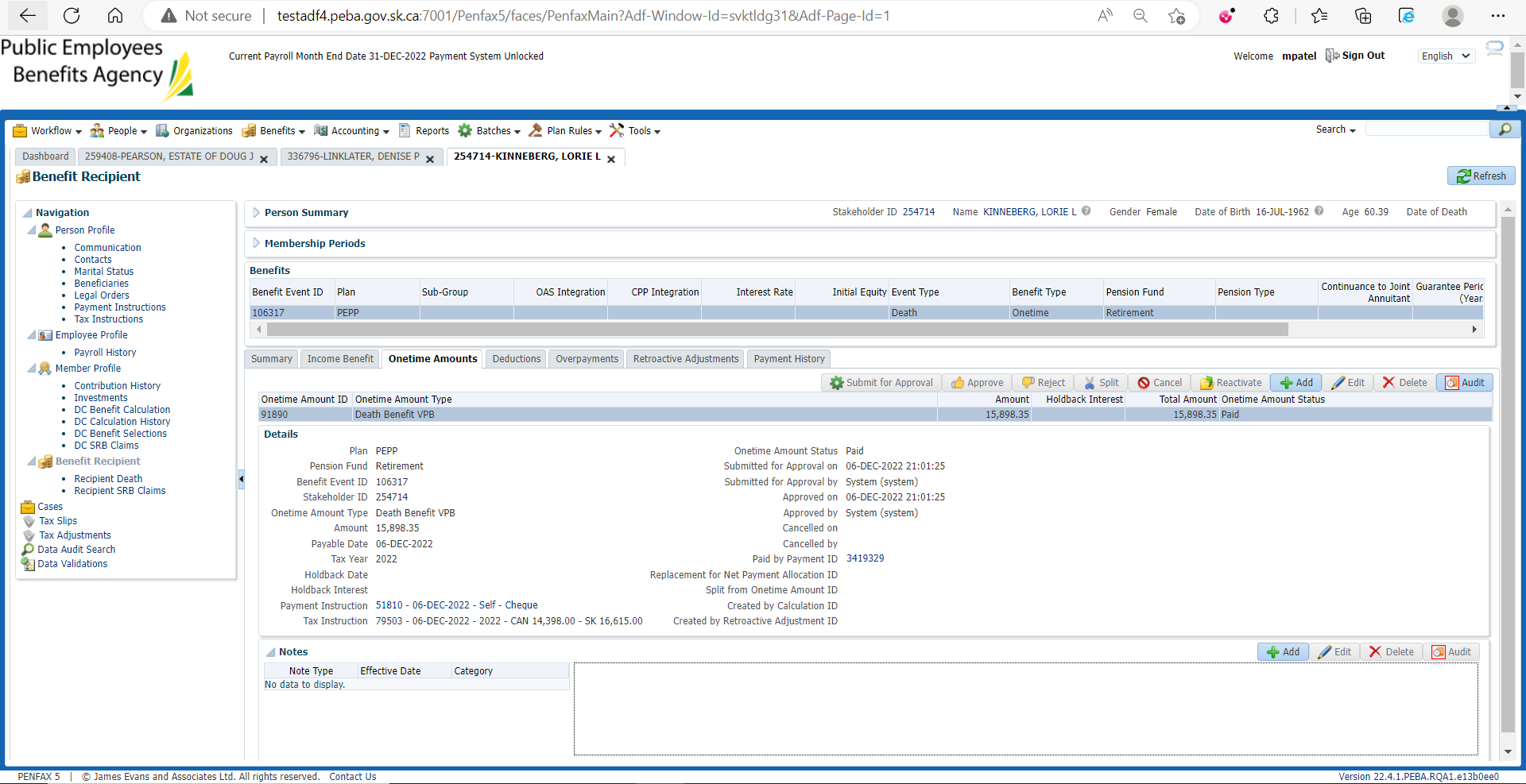

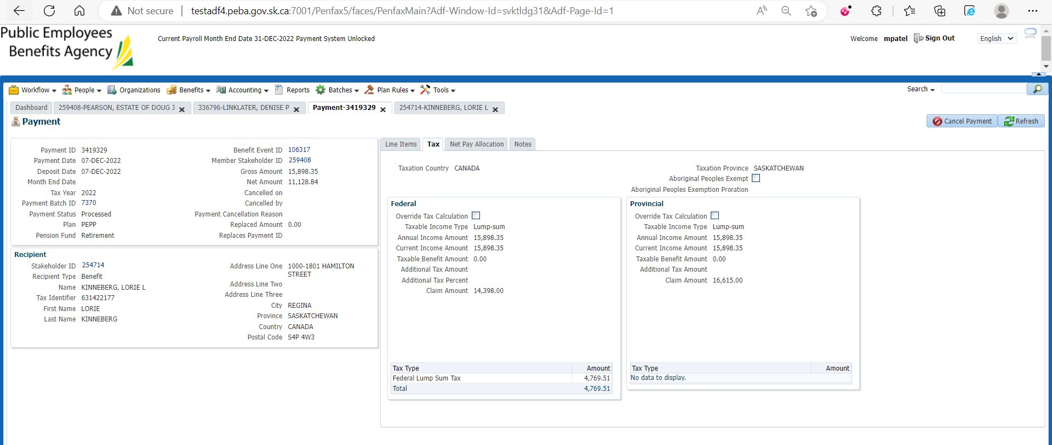

For Child 1

In VPB Beneficiary Profile go to Communications under Person Profile

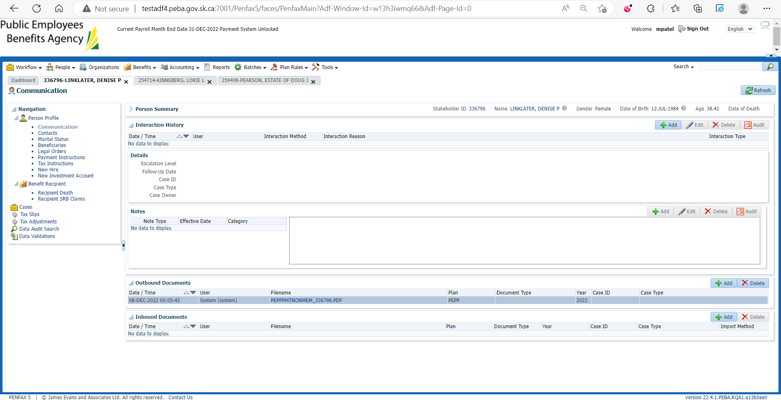

Download and Open that PEPP payment to Non-member Letter

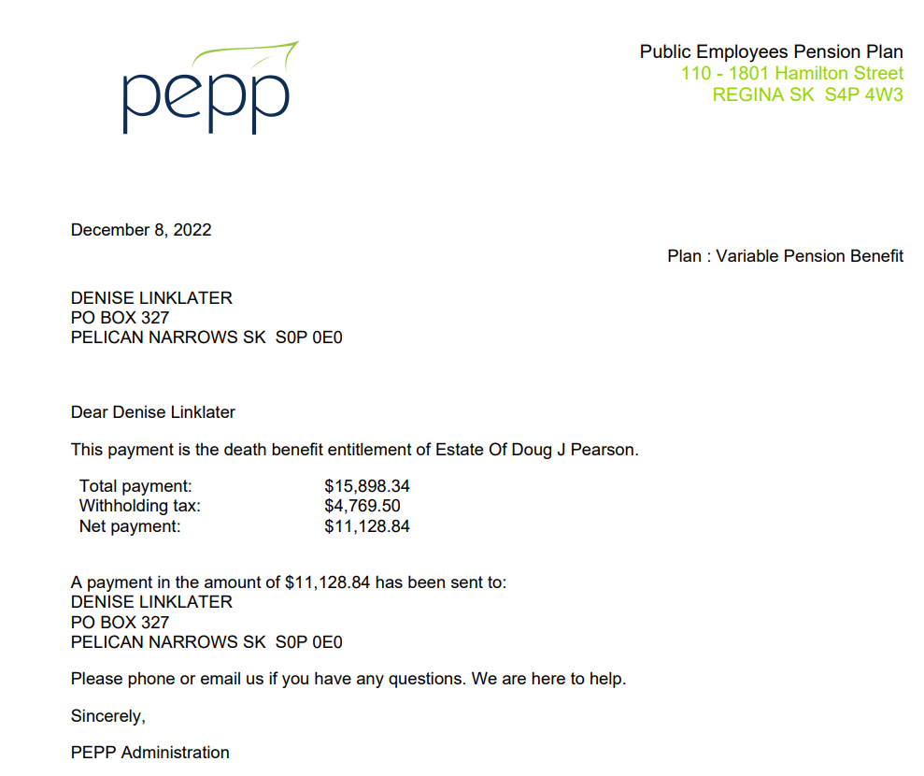

For Child 2

In VPB Beneficiary Profile go to Communications under Person Profile

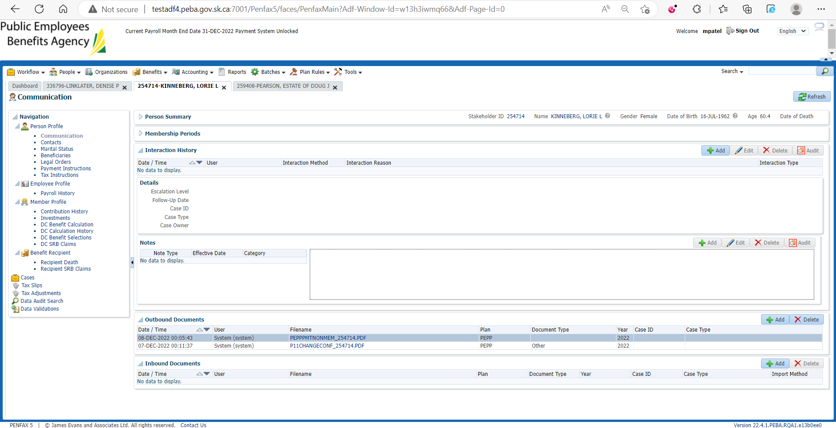

Download and Open that PEPP payment to Non-member Letter

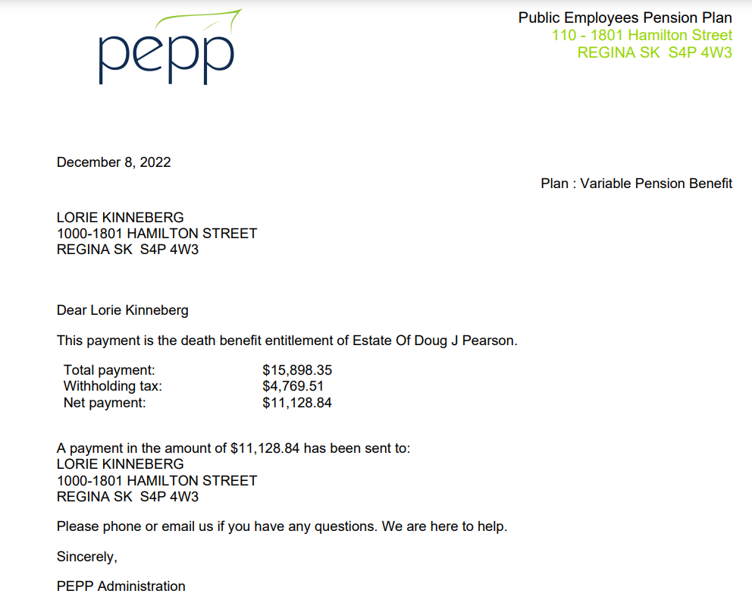

Check the Valuation Report. Go to Batches -> Batch Processes. Search with “PEPP Valuation Report” as Batch Process Type and open the very first record in the list (batch processed a day before).

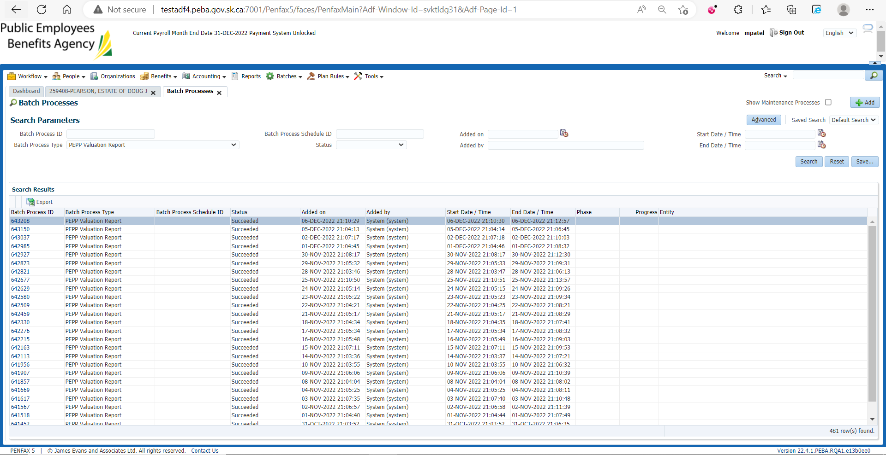

Go to Files tab and open VPB valuation excel

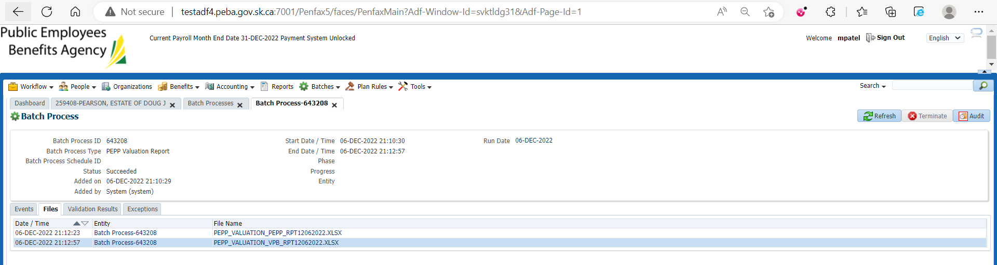

Section Seven

